**Graded Project**

**Problem Statement:**

A Pharmacy shop that has millions of customers’ needs to create a website for its products. As they have hundreds of offline orders coming in every day and it is becoming difficult to keep track of it, your organization has taken up the project. The pharmacy also has a tie-up with various Diagnostic centers where the pharmacy will take samples from the patients at their doorstep and analyses them in the lab. The report will be sent via mail and a hard copy if requested. And your team has asked you to develop a Homepage for the products and the Lab Test form. The requirements of the Homepage are as follows.

***Note:*** *There will be only two pages one is the Homepage and the other will be the Lab test form. Please watch a demo video of the project for a better understanding****.***

1. Create a Header (“**Pharmacy**”), Footer **(“@copyright. Only for demonstration purposes**”) and align both to the center.
2. Create a Horizontal Navigation Bar after the Header with the required tags to link. When hovering on any of the links, make sure the background color changes accordingly. The tag names are as Follows.

(All drop down list should have background color effect when hovered)

* 1. Home
  2. Our Medicines
     1. When Hovered on this, show a dropdown list of links for Fever, Muscle Pains, (Cold & Cough)
  3. Health Care
     1. When Hovered on this, show a dropdown list of links for Baby Care, Skin Care, Home Care, Personal Care, and Pet Care
  4. Lab Test
     1. When Clicked on Lab Test link, open a form to book the slot.
  5. When the web page is scrolled, make sure that the navigation bar is still seen on the top of the web page.

(Look at the below images for your reference.)

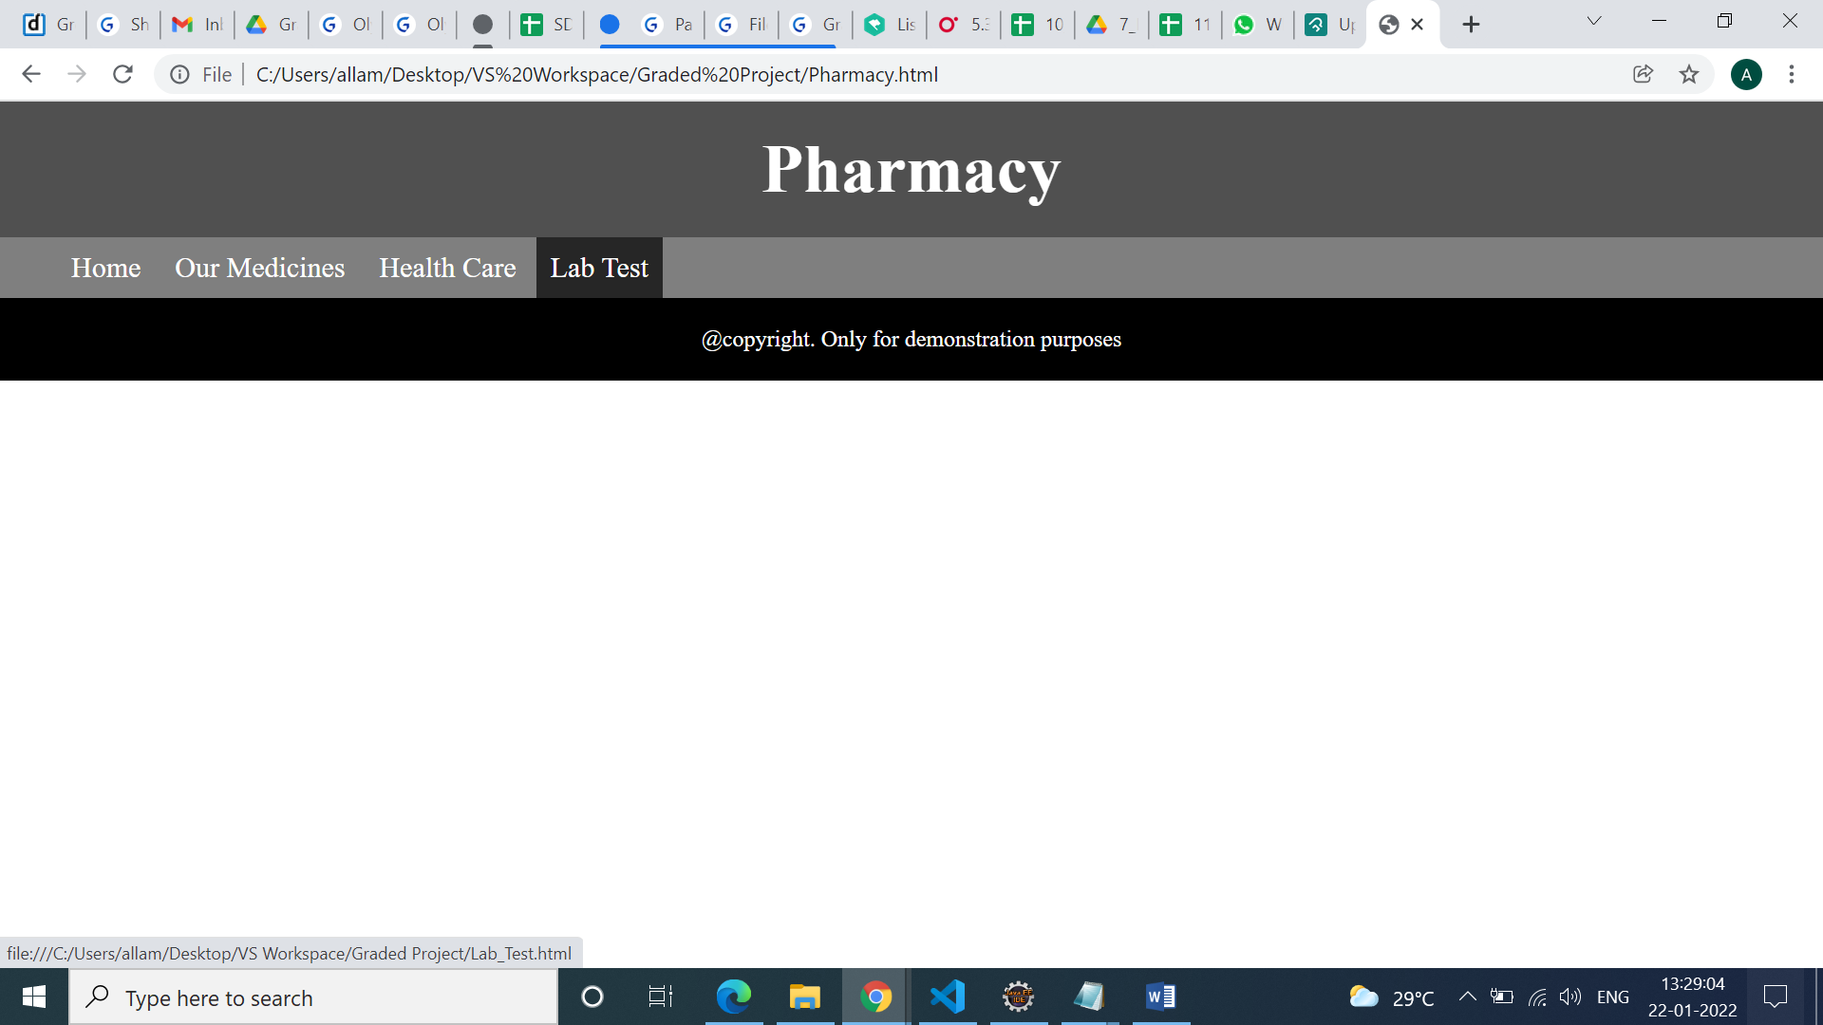

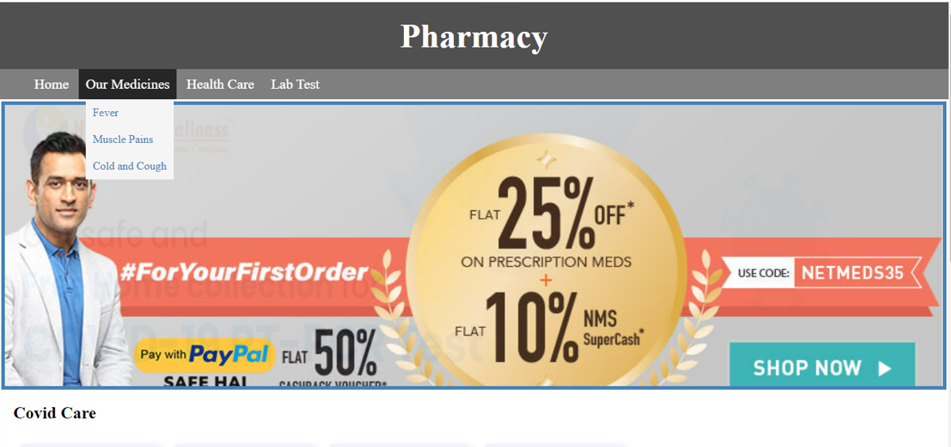

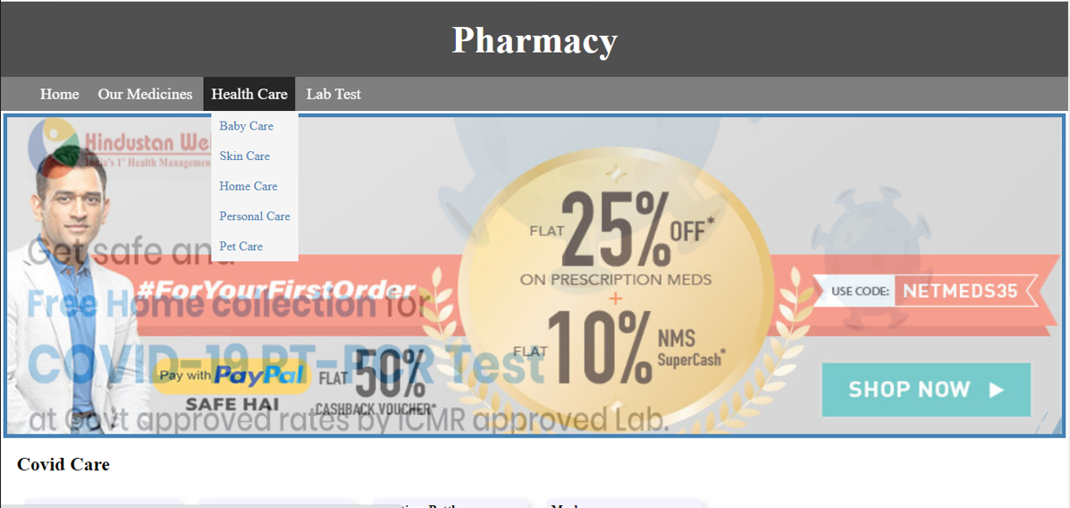

1. After the navigation bar on the webpage, next thing is to show offers or some information in the form of images.
   1. Use the Images given in the project file and create a simple animation to show them one after the other infinite times. Apply a border of 2px solid steel blue.
2. After Animation creates two sample sections of the products as **Covid Care** and **Diabetes Care.**
3. Under Each of them display products with product name, image, Price, and Price after the Offer and Add to Cart option. When clicked on the button, the background color should change to rgb(250, 234, 230) and the border should change to rgb(0, 255, 76). When hovered over each product, slightly increase its width and height of it. Make Sure the output looks as shown below.

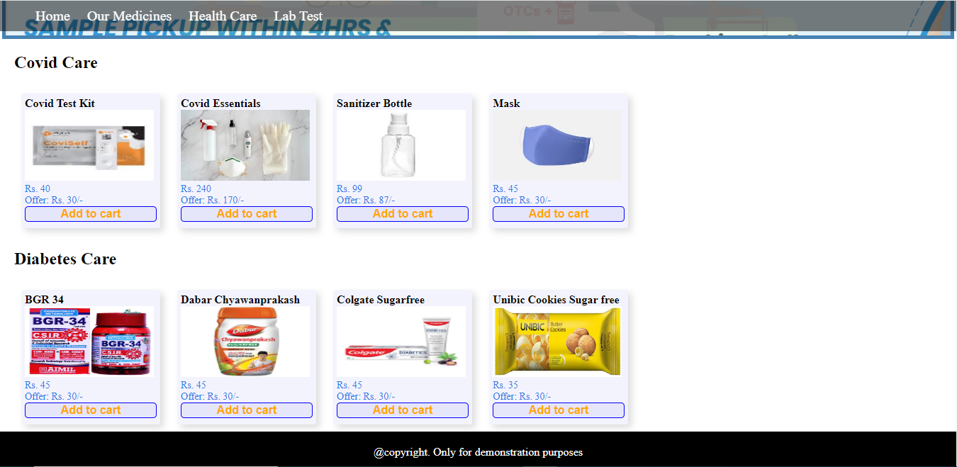

1. When clicked on Lab Test in the Navigation bar, a form shall open with validation on a new page with the following details.
   1. Form shall have Patient Contact Details as follows.
      1. Full Name
      2. Patient Id if exists
      3. Contact Number
      4. Email Id
   2. Address
      1. House Number
      2. Street
      3. Area
      4. District (List. Make Sure the first option is “Chosen”)
   3. Choose the Test Type. Show a message (Check at least one box without fail)
      1. CBC
      2. Complete Urine
      3. Lipid Profile
      4. Thyroid Stimulating Hormone (TSH)
      5. Glucose Test
   4. Do you want a hard copy of the report also?
      1. Yes
      2. No
   5. Select Your Comfortable Date and Time
      1. Date
      2. Time
   6. Reset and Submit button
2. On the Right Side of the form insert an image that will not move when you scroll the page. Make Sure Your form looks as below.

***Note: form should be aligned in the center of the webpage***.

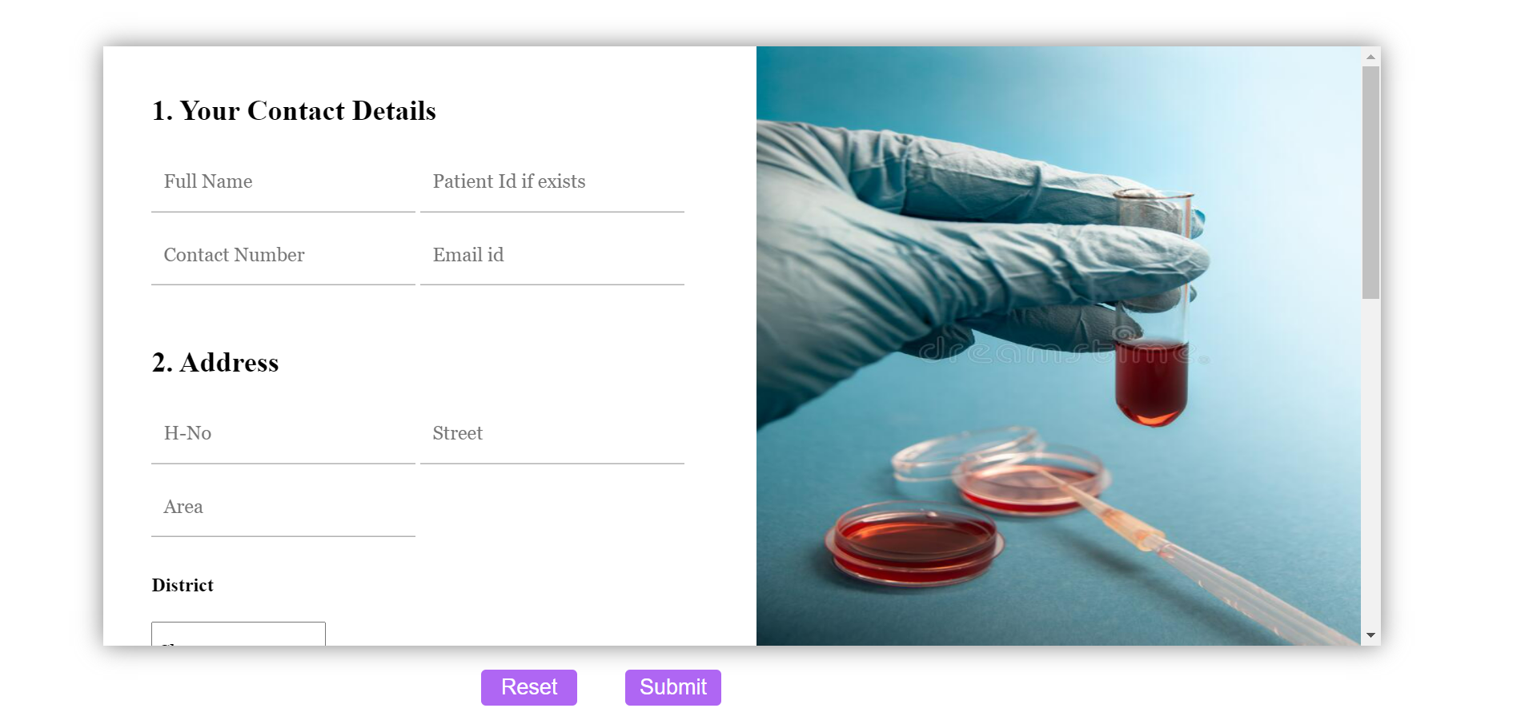

**General Instructions:**

1. Make sure you create a responsive form or web page (when the browser is resized your form and web page should behave accordingly).
2. Provide padding, margins, page titles, and page names where needed.
3. Write all your CSS code in a. CSS file.
4. Upload all your files along with images. Make sure images are well sorted.
5. Name the files appropriately as homepage.html, homepage.css, labtest.html and labtest.css
6. Do not upload zip/compressed files
7. Make sure all the links/URL are provided according to the project structure keeping in mind for GitHub and not related to the local machine.